**TEST BANK**

*to accompany*

Johnson-Sheehan

**TECHNICAL COMMUNICATION TODAY**

***Sixth Edition***

**Richard Johnson-Sheehan**

*Purdue University*

*Revised by*

**William West**

*University of Minnesota*

Pearson Logo

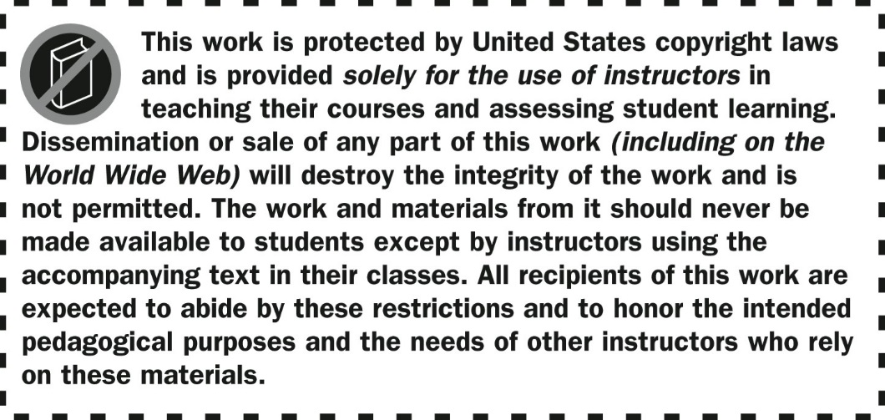

Pearson Logo

Copyright © 2018 by Pearson Education, Inc. or its affiliates.

All Rights Reserved. Printed in the United States of America.

This publication is protected by copyright, and permission should

be obtained from the publisher prior to any prohibited reproduction,

storage in a retrieval system, or transmission in any form or by any means, electronic, mechanical, photocopying, recording, or otherwise. For information regarding permissions, request forms and the appropriate contacts within the Pearson Education Global Rights & Permissions department, please visit www.pearsoned.com/permissions/.

ISBN 10: 0-13-443238-X

ISBN 13: 978-0-13-443238-0

**CONTENTS**

CHAPTER 1: Communicating in the Technical Workplace 4

CHAPTER 2: Communicating in a Reader-Focused Way 9

CHAPTER 3: Working in Teams 14

CHAPTER 4: Managing Ethical Challenges 18

CHAPTER 5: Starting Your Career 22

CHAPTER 6: E-mails, Letters, and Memos 26

CHAPTER 7: Technical Descriptions and Specifications 30

CHAPTER 8: Instructions and Documentation 34

CHAPTER 9: Proposals 38

CHAPTER 10: Brief Reports 42

CHAPTER 11: Formal Reports 46

CHAPTER 12: Thinking Like an Entrepreneur 50

CHAPTER 13: How to Be Persuasive 54

CHAPTER 14: Researching in Technical Workplaces 58

CHAPTER 15: Organizing and Drafting 62

CHAPTER 16: Using Plain and Persuasive Style 66

CHAPTER 17: Designing Documents and Interfaces 70

CHAPTER 18: Creating and Using Graphics 74

CHAPTER 19: Revising and Editing for Usability 78

CHAPTER 20: Presenting and Pitching Your Ideas 82

CHAPTER 21: Writing for the Internet 86

**CHAPTER 1**

**Communicating in the Technical Workplace**

***Quiz Questions***

MULTIPLE-CHOICE

1. Which of the following stages are typical of the process of technical writing?

a. planning and researching b. designing the graphics

c. improving the style d. a and c

e. None of these is correct.

2. Genres can primarily help you…

a. Shape your ideas into patterns familiar to your readers

b. Improve your style

c. Create a project timeline

d. Proofread.

e. Work in team projects

3. When you have finished drafting and designing the document, you are a. finished with the bulk of the project.

b. a little over halfway finished. c. just beginning.

d. ready to publish.

4. Technical communication is a. reader centered.

b. writer centered.

c. document centered. d. company centered.

5. Key characteristics of technical writing do NOT include or are NOT…

a. Documents and presentations that are highly mobile, interactive, and adaptable

b. Documents are writer-centered

c. Communication is shaped by ethical, legal, and political issues

d. Team-Oriented and highly visual

6. Which of the following skills are among the most important in the technical workplace?

a. Oral communication b. Graphic design

c. Fluency in another language d. a and c

e. None of these is correct.

7. Which of the following statements about genres is true?

a. Genres are formulas.

b. Genres should be followed mechanically. c. Genres are not flexible.

d. Genres reflect the activities and practices of scientific and technical workplaces. e. All of the above are correct.

8. Which of the following steps is important when beginning the process of technical writing?

a. Obtaining budget approval b. Creating a document design

c. Devise a strategic plan

d. Establishing organization

9. Which of the following statements about document design is NOT true?

a. Your readers will expect your technical documents to be well designed. b. Readers prefer documents that use effective graphics and layout.

c. Most readers care about the information instead of the design. d. Readers are “raiders” for information.

10. Which of the following statements about the workplace writing process is NOT true?

a. The writing process consists of the following stages: planning and researching, organizing and drafting, improving the style, designing, and revising and editing.

b. Technical writing genres are helpful for organizing information into patterns your readers will expect.

c. Computers, the Internet, and instant forms of communication have lessened the need for teamwork.

d. Technical writing in the workplace is a blend of actions, words, and images. Readers expect technical documents to use writing, visuals, and design.

TRUE/FALSE

11. You should give your readers as much information as possible about your topic.

12. Documents can contain small errors without being rejected by readers.

13. The technical writing process is linear.

SHORT ANSWER

14. What is technical communication?

15. Explain the differences in writing a college essay and writing effective technical communication.

EXERCISES

**Exercise 1:**

Your task in this assignment is to work with a group to develop a “Course Mission Statement” in which you lay out your expectations for the course, your instructor, and yourselves. To write the mission statement, follow these steps:

**a.** Use an Internet search engine to find examples of mission statements. Just type “mission statement” into Google, Bing, or Yahoo.

**b.** In class, with your group, identify the common characteristics of these mission statements.

Pay special attention to their content, organization, and style. Make note of their common features.

**c.** With your group, write your own course mission statement. Be sure to include goals you would like the course to meet. You might also want to develop an “ethics statement” that talks about your approach to ethical issues associated with assignments, course readings, and attendance.

**d.** Compare your group’s course mission statement with other groups’ mission statements. Note places where your statement is similar to and different from their statements.

When your course mission statement is complete, it should provide a one-paragraph description of what you are trying to achieve in your class.

**Exercise 2:**

Locate a document that is used in a technical workplace through a search engine like Google, Bing, or Yahoo. To find documents, type in keywords like “report,” “proposal,” “instructions,” and “presentation.” What characteristics make the document you found a form of technical communication? Develop a two- minute presentation for your class in which you highlight these characteristics of the document. Compare and contrast the document with academic essays you have written for your other classes.

***Answer Key for Chapter 1***

MULTIPLE-CHOICE

1. d

2. a

3. b

4. a

5. b

6. a

7. d

8. c

9. c

10. c

TRUE/FALSE

11. False

12. False

13. False